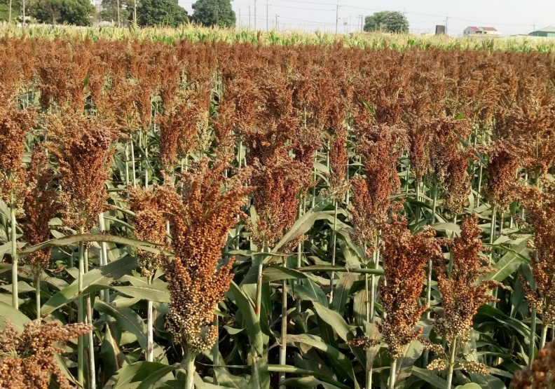

You produce, we sell

Solution To Food Waste In Tanzania

October 2021

**Authors:** Chenhao Zhang,Han Zhang, Hang Su, Puxi Cao, Yifan Zhou

**Address Information**

Zhongyanghuafu, Shengcheng District, Shouguang,

Shandong, China

**262700**

**Phone:** +61 2 6125 5394 | **Email: u7238847@anu.edu.au**

Content

[Abstract 4](#_Toc85762258)

[Problem statement 4](#_Toc85762259)

[Solution 5](#_Toc85762260)

[Improved-granaries 5](#_Toc85762261)

[Market 9](#_Toc85762262)

[Prototype 12](#_Toc85762263)

[Conclusion 14](#_Toc85762264)

[Reference 15](#_Toc85762265)

## IMG_256Abstract

|  |  |  |
| --- | --- | --- |
| Smallholder agriculture is the mainstay of Tanzania’s agricultural production. However, the lack of storage facilities and marketing channels has caused huge waste of agricultural products after receipt, and informal marketing arrangements have also disadvantaged farmers. We proposed a plan of integrated model of warehousing and processing to help local people increase their income by developing storage and sorghum processing industries in Singida. |  |  |

## Problem statement

Agriculture is the lifeblood of Tanzania's national economy, and smallholder agriculture is the mainstay of agricultural production, accounting for more than 80% of the cultivated land used (Foreign Economic Cooperation Center of the Ministry of Agriculture of China, 2018). In Singida, due to climate conditions, sorghum is grown on a large scale. However, for a long time, Tanzania's agricultural production has been an extensive business model with low input and low output, the added value of the product is very low. Most agricultural products processing activities are almost entirely carried out manually by women. The product also lacks sales channels.

Moreover, the shortage and unreasonable use of storage facilities resulted in huge post-harvest losses, which accounted for approximately 15%-20% of the total post-harvest losses (Taruvinga 2018). For farmers with excess grain, the existing household-level storage of grain for commercial purposes has a high unit cost and is susceptible to the influence of buyers, middlemen and agro-processors. Although community warehousing has been greatly promoted in the past decade, most of these warehouses are underutilized. This can be blamed on informal marketing (Taruvinga 2018). Meanwhile, the damage caused by storage pests, including rice borers and rice weevils, is also serious. About 16% of farmers believe that this is the most important factor causing food losses. The survey results show that the lack of knowledge and skills of farmers in post-harvest management is also an important cause of food waste (Abass 2014).

## Solution

We hope to take advantage of the geographical advantages in Singida to develop storage and food processing industries and radiate to the surrounding areas. Establishing granaries or transforming existing granaries can alleviate waste. Establishing sorghum processing plants that are closely linked to these storage facilities to process sorghum into other products can increase the purchase of sorghum and provide stable sales channels, increase added value, create more employment positions, and make the products easier to sell, thereby boosting the income of farmers and workers.

#### storage facilities

#### Granaries Location

The storage is mainly for Tanzanian sorghum, and is set up in Singida, the central region of Tanzania, which is an area where sorghum is planted intensively in the central region. The reasons for choosing a site in this area are as follows:

* Large yield of sorghum

The table below is the sorghum production in Tanzania from 2015-2020 (United States Department of Agriculture 2021).

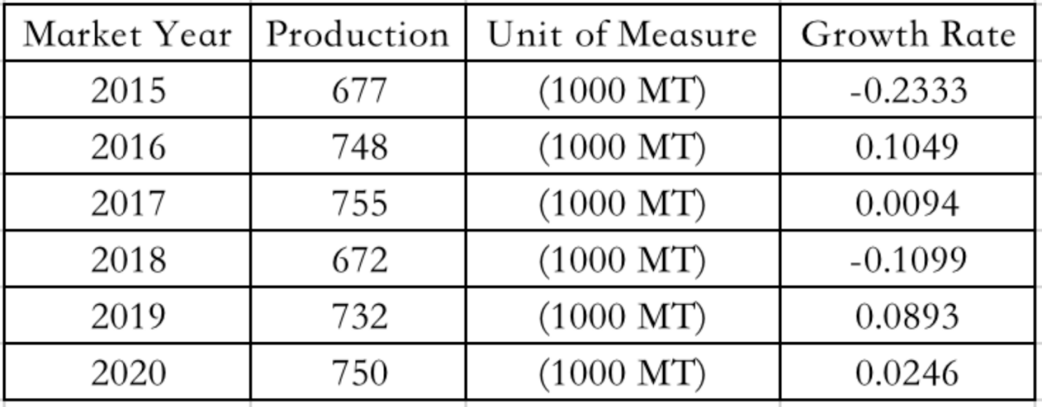

Fig1. Sorghum production in Tanzania from 2015-2020

* Close to the origin of sorghum

The map below is showing the eleven-agriculture crop distribution in Tanzania (Asdpll 2017). We can see that sorghum is mainly grown in center area.

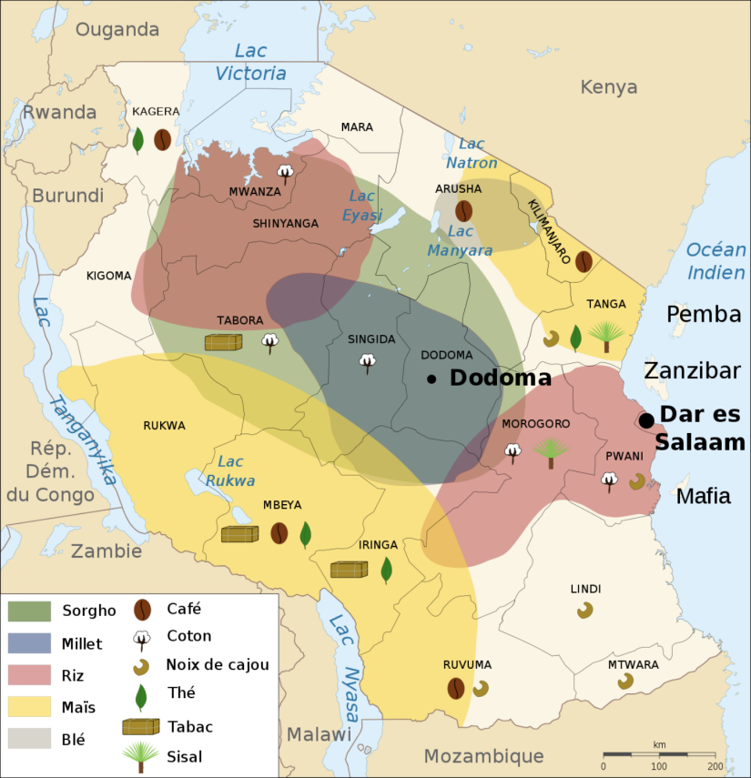

Fig.2 Map of crop distribution in Tanzania

* Storage of sorghum in a suitable climate

According to Climatelinks (2020), the climate of Tanzania is divided into hot and humid areas along the coast and cold and dry areas in the central plateau. The storage of sorghum requires a cool and dry environment, so it shows again that locating our granaries in the middle areas is an appropriate choice.

#### Granaries Infrastructure

* Storage of sorghum in a suitable climate

We’ll use local improved woven basket granary called kihenge. It is constructed of bamboo or other sticks. Pest control is by insecticide admixture. They range in capacity from 1t to 5t (Postharvest Loss Reduction Centre 2015).



Fig.3 kihenge

* Improved-granaries in Mozambique

According to data, few project to improve the storage environment in Tanzania have been successful, while in his neighbor Mozambique, many practical storage technologies has been launched to support food storage (Coulter & Schneider 2004).

We can refer to the improved-granaries of Mozambique. Mozambique’s pest and moisture problems are very serious, so its granary technology is very developed. Improved-granary is a kind of traditional and locally available resources to build granaries, which can prevent moisture and pest control. Its good storage can help small farmers sell off-season (Cunguaraab & Darnhofera 2011).

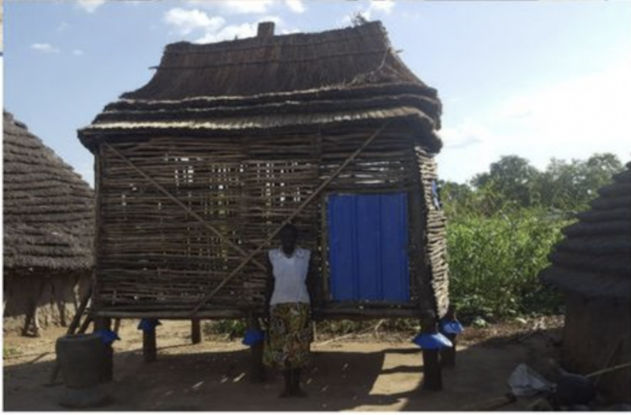

Fig.4 Improved-granary 1

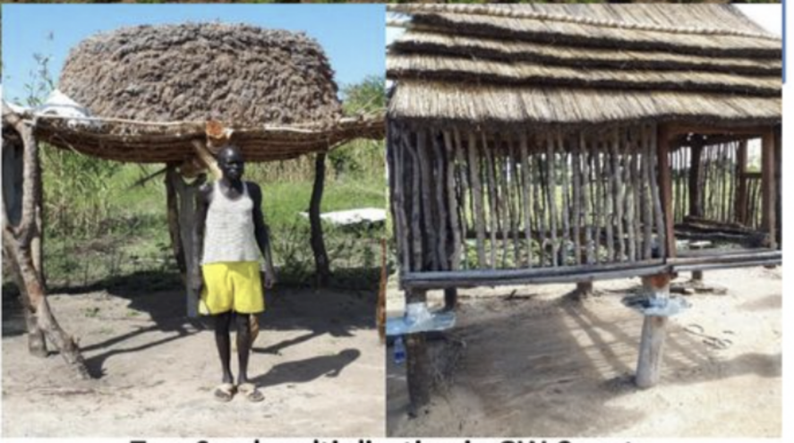

Fig.5 Improved-granary 2

#### How it works

* First, look for the villages with a large area of sorghum planting in the central region of Tanzania and build small granaries based on this village or community because it is convenient for the centralized preservation of sorghum.
* Hire people with higher local prestige as warehouse managers.
* Fees are charged on a quarterly basis. The price in the off-season is lower, and the price in the peak-harvest season is higher. The specific prices refer to the local consumption level.

#### Sources of funds

In 2020, Tanzania’s NMB Bank has allocated 1.9 billion local currency (approximately US$820,000) to support the construction of farmer granaries across the country (Construction Review Online 2021), so we can cooperate with local government and bank to build these granaries.

### Market

Speeding up the processing of sorghum after harvest is also an important way to reduce food losses. Building sorghum processing plants attached to the warehouse not only enables the storage system to operate under low load conditions, but also increases the value of sorghum. Unscientific farming practices and lack of commercial markets lead to low commercial value of sorghum and reduce people's investment in sorghum (CRAFT).

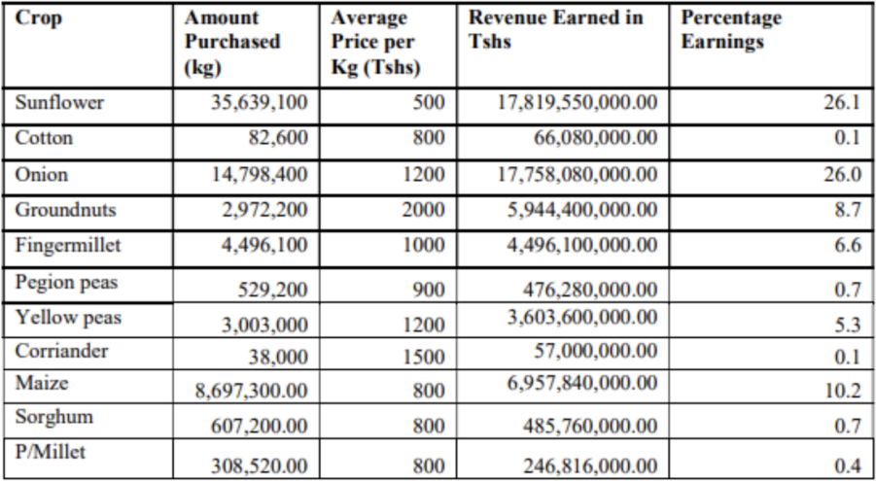

Fig.8 Amount and Value of Cash Crops Purchased by District

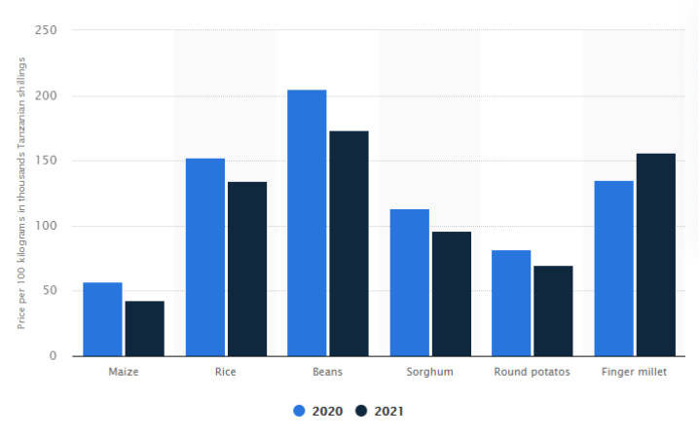

Fig.9 Average wholesale price of major food crops in Tanzania in June 2021, compared to the same month of the previous year（in thousand Tanzanian shillings per 100 kilograms）

In Singida, sunflower has become an important source of income for local farmers. The government promotes the construction of processing plants and converts sunflower seeds into sunflower oil and sunflower cake, which not only meets the needs of locals, but also allows transactions (Isinika & Mdoe 2021). Sorghum is mainly grown for household consumption, and the excess sorghum is sold near the residence. Compared with sunflower, sorghum has a low income.

However, sunflower has strict requirements on the environment, and a single agricultural product industry chain is less resistant to risks. The local government is also promoting the development of diversified agriculture. If the above two problems can be solved, the potential of sorghum will be greatly improved (Oxford Business Group).

TARI (Salaam 2021) and scientists (ICRISAT) are solving the first problem by improving the sorghum variety and promoting new farming methods. Our prototype enables products processed with sorghum to enter the market, increasing the economic value of sorghum. Compared to selling sorghum, processed food has higher economic value and a broader market in Tanzania and Africa. For example, Sorghum beer is the most popular traditional grain alcoholic beverage in Africa (Lay 2015). It is widely consumed in rural and urban areas and is usually used in traditional ceremonies and social and cultural activities. Located in central Tanzania, Singida has transportation advantages. The branch of Central Line and Road links enable processed products to reach retail stores in major cities or export ports. Sunflower needs skilled workers and refining equipment. In contrast, sorghum processing on labor and equipment requirements are lower. What’s more, the factory built near the warehouse ensures the continuous and stable output of Sorghum products. Therefore, this warehouse-processing integrated model is of great significance to help local economic development and reduce food losses.

## Prototype

To build our warehousing system, firstly we will seek for potential clients who needs sorghum as raw material, establish long-term cooperation relationship with them and provide sorghum. In return, investments are needed from client. Then, investments will be used in building better warehousing and processing plant for processing sorghum in primary stage.

There are four benefits for client joining our project. Firstly, client will be able to save part of transportation cost. Warehousing and processing infrastructures will be built in Singida nearing to each other whereby there will be less transportation cost from warehousing to processing. Meanwhile, Singida located at central Tanzania and connecting to the main line by Singida branch of the central line which make its transportation more convenient. Secondly, client will be able to save part of warehousing cost. Semifinished products will be easier to store than raw material because they are more difficult to decay, which can reduce warehousing cost. Thirdly, client will be able to save part of labor cost. Warehousing and processing infrastructures are both built in Singida where there are lots of available cheap labor currently. Lastly, client can save part of purchase cost. As part of cooperation agreement, small holders will reduce their unit profit of producing to exchange more productivity and sales rate through building better warehousing and processing infrastructures.

There are three benefits for local small holders. Firstly, their post-harvest wasting problem will be alleviating. By better warehousing and primary processing, sorghum will be more difficult to decay. Secondly, there will be more job opportunities. Both management of warehousing and processing need lots of labors which does not need high education. Thirdly, they can gain more profit from long-term perspective. Although they will reduce unit profit within the cooperation, their productivity and sale rate will increase due to better warehousing, processing and stable client. Meanwhile, warehousing and processing infrastructures are permanent benefits which will still benefit local economy after the cooperation.

As for the partner, for example, companies of Tanzania local beer industry would be a potential target. Beer is an important part of Tanzanian society, and its sales and taxes contribute a lot for local economy. Meanwhile, Tanzanians are very proud and confident of their local beer brands. However, over 90% of the national consumption is homemade or from the informal sector because bottled beer is too expensive for most of the people. If the price of bottled beer decreases, Tanzanians’ local beer brands will be favored. Meanwhile, because its high quality and convenience of shipping, there might be good abroad market for Tanzanians’ local beer brands. Thus, it is likely local beer company will be happy to join the project to reduce their cost and increase their reputation locally.

## Conclusion

Sindiga, the central railway hub of Tanzania, where sorghum is planted by smallholders on a large scale. However, the extensive business model, low added value of the raw products, lack of modern and effective storage facilities and sales channels resulting in heavy post-harvest loss have been marking the feature of sorghum production in Sindiga. This situation can be changed by responsible innovation covering the developing storage and food processing industries of this project. For the storage facilities, a massive modern storage industry cannot be established in the short term due to the local economic status, improved local granaries are considered instead. The primary storage center consisted by these improved traditional granaries can be set up in some large-scale village which has a relatively high yield of sorghum production, and this setup warehouse can be managed by local persons with high prestige, all these building fees can be funded by Tanzania’s NMB bank’s supporting project aims to support the construction of farmer granaries across the country. Also, speeding up of the sorghum processing plants attached to the warehouse reduce the transportation expanse, the transportation and storage loss of sorghum, and increase local employment because of the relatively low requirement of labor’s skill and equipment. Compared with the raw products, processed sorghum has a higher added value and has a much broader market all over Tanzania and Africa.

Seek for the clients and outsourcing investment is the most critical and the last step to implement the solutions come up with by this project, which benefits both the client and locals. The biggest benefit for our client is they can save much on transportation and storage because Sindiga is the railway hub of central Tanzania and the low distance between the storage center and the processing facilities stated in the solution of our project. In addition, the greatly increasing of the yield of sorghum by reducing the post-harvest wastage through building more storage facilities and produce the semi-finished products which is more difficult to decay will reduce the unit profit of producing and increase the productivity, which can greatly lower the purchasing cost of the client. The biggest benefit for the locals is the employment rate can go up because storage and processing need many low-skilled laborers which can be provided by local area on a large scale, benefiting local area’s economic growth and a greater perspective on the development of sorghum production industry can be given.

## Reference

Foreign Economic Cooperation Center of the Ministry of Agriculture of China [2018, *Conditions and Characteristics of Tanzania's Agricultural Development*, viewed 20 October 2021, http://www.agri.cn/V20/ZX/sjny/201811/t20181113\_6283410.htm](http://www.agri.cn/V20/ZX/sjny/201811/t20181113_6283410.htm)

Taruvinga, C 2018, *Tanzania Cereal Storage Scoping Mission*, viewed 20 October 2021, <https://www.canr.msu.edu/fsp/news/Paper_2.1._FAO_Cephas_Taruvinga.pdf>

Abass, AB, Ndunguru, G, Mamiro, P, Alenkhe, B, Mlingi, N & Bekunda, M, 2014, Post-harvest food losses in a maize-based farming system of semi-arid savannah area of Tanzania, *Journal of Stored Products Research*, Vol. 57, pp. 49-57, viewed 20 October 2021, <https://core.ac.uk/download/pdf/82311085.pdf>

United States Department of Agriculture 2021, *I United Republic of Sorghum Production by Year in Tanzania*.

Asdpll 2017, *Tanzania Agriculture Map*, viewed 20 October 2021, <https://asdp.kilimo.go.tz/index.php/resources/view/tanzania-agriculture-map>

Climatelinks 2020, *Tanzania*, viewed 19 October 2021, <https://www.climatelinks.org/countries/tanzania>

Postharvest Loss Reduction Centre 2015, *Tanzanian kihenge*. viewed 19 October 2021, <https://postharvest.nri.org/16-loss-reduction/55-tz-kihenge>

Coulter, J & Schneider, K 2004, *Feasibility Study of Post-Harvest Project in Mozambique and Tanzania*, viewed 19 October 2021, <https://www.shareweb.ch/site/Agriculture-and-Food-Security/focusareas/Documents/phm_coulter_study_mozambique_tanzania.pdf>

Cunguaraab C & Darnhofera I 2011, 'Assessing the impact of improved agricultural technologies on household income in rural Mozambique’, *Food Policy*, vol 36, Issue 3, pp. 378-390, viewed 19 October 2021, <https://econpapers.repec.org/article/eeejfpoli/v_3a36_3ay_3a2011_3ai_3a3_3ap_3a378-390.htm>

Construction Review Online 2021, *NMB Bank approves US $817,204 for construction of granaries in Tanzania*. viewed 19 October 2021, <https://constructionreviewonline.com/news/tanzania/nmb-bank-approves-us-817204-for-construction-of-granaries-in-tanzania/>

CRAFT, *Climate Change Risks and Opportunities*

Isinika, A & Mdoe, N 2021, *Monocrop or diversified enterprise portfolio? Lessons for inclusive commercialization from Singida Region, Tanzania*, viewed 20 October 2021, <https://www.future-agricultures.org/blog/monocrop-or-diversified-enterprise-portfolio-lessons-for-inclusive-commercialisation-from-singida-region-tanzania/>

Oxford Business Group, *Already Tanzania's largest sector, agriculture continues to post positive trends*, viewed 20 October 2021, <https://oxfordbusinessgroup.com/overview/growth-ground-already-largest-economic-sector-agriculture-continues-see-positive-trends-many-areas>

Salaam, D 2021, *Tanzania: Tari Set to Boost Sorghum Production*, viewed 20 October 2021, <https://allafrica.com/stories/202101210202.html>

ICRISAT. *Farmers in Tanzania Urged to Embrace Drought Tolerant Crops*, viewed 20 October 2021, <https://www.icrisat.org/farmers-in-tanzania-urged-to-embrace-drought-tolerant-crops/>

Lay, K 2015, ‘Sorghum in Beer Increases Crop Production in Africa’, *BORGEN Magazine,* viewed 20 October 2021, <http://www.borgenmagazine.com/sorghum-in-beer/>.